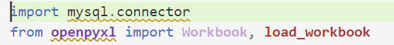

Import necessary libraries.

Import mysql.connector to use Python APIs with MySQL software in order to access the database.

Import openpyxl to work read Excel files using Python.

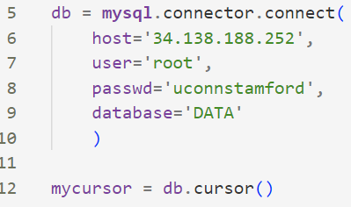

Connect to our backend database which has an external IP of 34.138.188.252.

Access the DATA schema which contains a table for merged_data.xlsx data called ‘Stock’

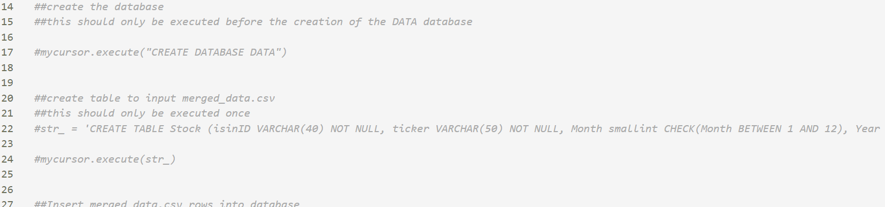

Run 14-17 only once if the DATA database is not already created.

Run 20-24 only once if the Stock table is not already created in the DATA database.

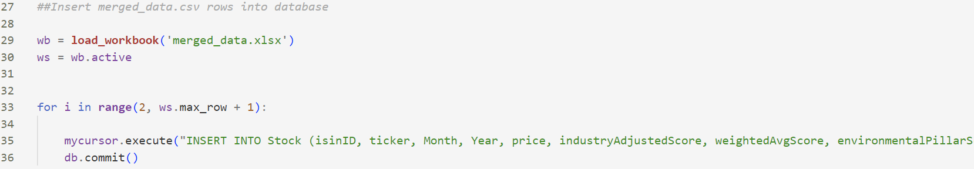

Read excel workbook and loop through it. Insert each row of the excel sheet into the newly created DATA database table *Stock*.

Commit the changes so that the rows save after the Python program terminates.